PHC Interface Tool
The PHC Interface tool is available to all members of the project. It allows project staff to see exactly what Deliverables, Concerns and Action are assigned to them and make clarifications and updates via a comments procedure. The PHC Interface is directly linked to the PHC ATS and Deliverables Trackers and acts as a simplistic method of update. In addition the PHC Interface shows a project report that grows in real time with the project.
Log In
The PHC Interface is available at http://petrotrin.order-efficiency.com and log in details will be provided to individuals when required. To log in enter the user name and password that you have been provided with and click “Log In”:
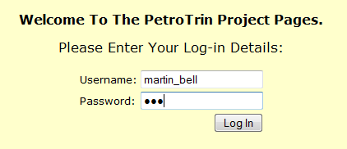
Dashboard Screen
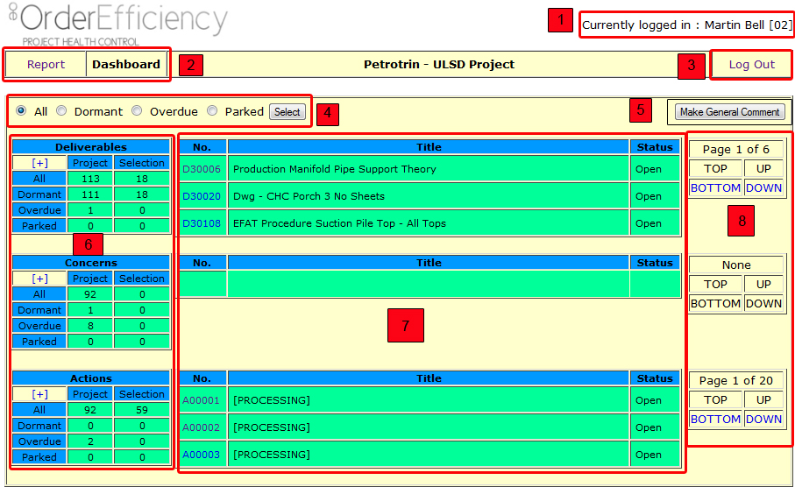
- Currently Logged In. This will be your name along with your unique PHC number in square brackets
- Report and Dashboard Views. By clicking the word you can switch between the Dashboard view and the written report.

- Log Out. Click the word to Log Out
- Selection Tool. This is where the user selects the items they want to peruse. Simply click the radio button and then press “select”
  - All – Shows everything assigned to the user
  - Dormant – All items that have not been updated in the last 30 days. These are very bad and should be immediately addressed
  - Overdue – Items containing a date that has now passed
  - Parked – items that have been frozen for a valid reason
- Make General Comment. The general comment button is a way of making a comment that is not necessarily related to an item assigned to you, or a comment that you would like PHC staff to look at or to be entered into the project info. Often general comments can contain sensitive information.
- Counts. This area shows counts of Deliverables, Concerns and Actions. The Project column shows all Deliverables, concerns and Actions Open in the Project. The Selection Column shows the count of Deliverables, Concerns and Action assigned to the user who is logged in. The selection counts are related to the selection made in Number 4.
- Detail Pane. This area shows some detail based on the selection chosen in Number 4:
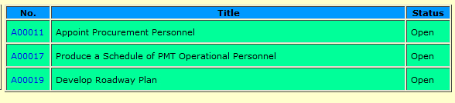
  - No. Is the ATS Number.
  - Title. The title of the Concern, Action or Deliverable.
  - Status. The Current Status of the Item
- Page Selection. This is a navigation panel to allow you to scroll through the pages of your selection

By clicking the Plus Button in the various counts:
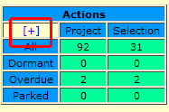
You can limit the view of the screen to just the Concerns, Actions or Deliverables List.
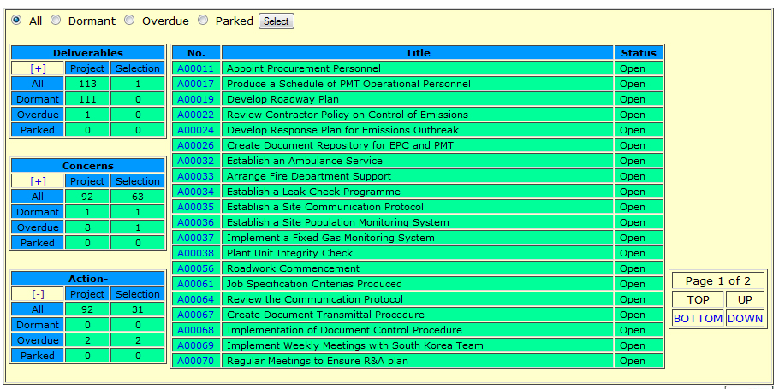
The Detail View.
The User is able to look at the detail of any Concern, Action or Deliverable by clicking its unique ATS number:
The detail view is all of the information about the item selected.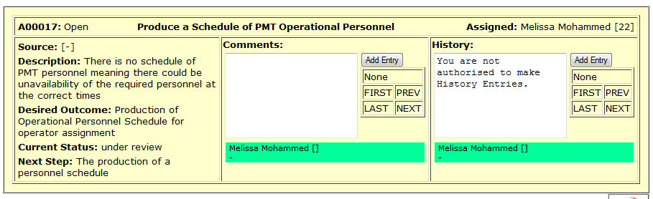
The information on the detail view shows the ATS Number, Title and Status of the Item at the top and then the Source, Description, Desired Outcome, Current Status and Next Step down the left hand side. In addition you can see any comments or history attached to the item and scroll through using the scrolling tools.
Adding a Comment
Finally a user is able to add a comment to any item. The comment can be to do with anything and will be processed by the PHC Consultant. Add a comment by entering your text into the white box and clicking the “Add Entry” button.
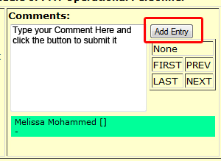
When you have submitted the comment an entry will be produced for others to see if they are re-assigned to the item:
